**Student Questions:**

1. Write a program that uses Boolean variables and logic to do the following:
   1. Read a high number and a low number from console input. The numbers must be less than 100.
   2. Create a continuous loop that starts with a count of 1 and increases the count by 1 each time through the loop
   3. Checks whether the count is between the low number and the high number and assigns the result of the check to a Boolean variable called “inRange”.
   4. Prints the message “Number is in range” if the value of inRange is true.
   5. Breaks out of the loop when the count gets bigger than 100.

hiNumber = int(input("Enter a high number less than 100:"))

lowNumber = int(input("Enter a high number less than 100:"))

loopCount = 1

while (loopCount <= 100) :

print("Loop count is", loopCount)

loopCount = loopCount + 1

inRange = (loopCount >= lowNumber) and (loopCount <= hiNumber)

if inRange :

print("Number is in range")

if (loopCount > 100) :

break

**Solution:**

1. Write a program that uses Boolean variables and logic to do the following:
   1. Read a high number and a low number from console input. The numbers must be less than 100.  
        
      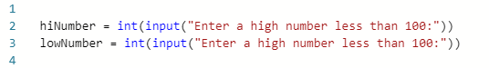
   2. Create a continuous loop that starts with a count of 1 and increases the count by 1 each time through the loop

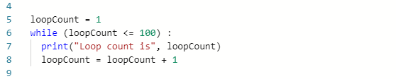

* 1. Checks whether the count is between the low number and the high number and assigns the result of the check to a Boolean variable called “inRange”.  
       
     
  2. Prints the message “Number is in range” if the value of inRange is true.  
       
     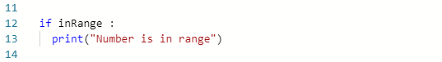
  3. Breaks out of the loop when the count gets bigger than 100.  
       
     